NAME: V S SRAVAN M
ROLL NO: A24126552268
BRANCH AND SECTION: CSM-B
COURSE NAME: FULL STACK WEB DEVELOPMENT
COURSE CODE: 23CM4121
Experiment: 03
Date:
Title: Working with Arrays and Functions in JavaScript
Objective:
To understand and implement core JavaScript array operations (indexing, mutation, filter, map, find, some) and function concepts (declarations, arrow functions, default parameters, template literals) by writing and executing two JavaScript programs.
System Requirements:
- Hardware: Processor (e.g., Core i5), RAM (e.g., 8GB), Storage.
- Software: Operating System (e.g., Windows 11 / Linux), Code Editor (e.g., VS Code), Node.js Runtime, Terminal.
Source Code:
arrays.js
// 1. Creating an array of numbers
const numbers = [10, 25, 40, 5, 80, 15];

// 2. Accessing elements by index (starts at 0)
console.log("First number:", numbers[0]); // Output: 10
console.log("Third number:", numbers[2]); // Output: 40

// 3. Modifying an item
numbers[1] = 30; // Changes 25 to 30

// 4. Adding and removing items
numbers.push(100); // Adds 100 to the end
numbers.shift(); // Removes the first item (10)

// 5. Checking the array length
console.log("Total items:", numbers.length);

// 6. Common Array Operations
// Filter numbers greater than 20
const bigNumbers = numbers.filter(num => num > 20);
console.log("Numbers > 20:", bigNumbers);

// Multiply every number by 2
const doubled = numbers.map(num => num * 2);
console.log("Doubled numbers:", doubled);

// Sample array of products in a shopping cart
const cart = [
{ id: 101, name: "Wireless Mouse", price: 25, inStock: true },
{ id: 102, name: "Mechanical Keyboard", price: 85, inStock: false },
{ id: 103, name: "USB-C Cable", price: 12, inStock: true },
{ id: 104, name: "Gaming Monitor", price: 220, inStock: true }
];

// 1. Array.prototype.find() - Find a single item by ID
const item = cart.find(product => product.id === 103);
console.log("Selected Item:", item.name); // Output: USB-C Cable

// 2. Array.prototype.filter() - Get only items that are in stock
const availableItems = cart.filter(product => product.inStock);
console.log("Available Items Count:", availableItems.length); // Output: 3

// 3. Array.prototype.some() - Check if any item exceeds $200
const hasExpensiveItem = cart.some(product => product.price > 200);
console.log("Has item > $200?:", hasExpensiveItem); // Output: true

// 4. Array.prototype.map() - Get an array of just the product names
const itemNames = cart.map(product => product.name);
console.log("Product Names:", itemNames);
functions.js
// 1. Basic Function declaration
function greetUser(userName) {
return `Hello, ${userName}! Welcome back.`;
}

// Calling the function
const message = greetUser("Alex");
console.log(message); // Output: Hello, Alex! Welcome back.

// 2. Function with multiple parameters & math calculation
function calculateDiscount(price, discountPercent) {
const savings = (price * discountPercent) / 100;
const finalPrice = price - savings;
return finalPrice;
}

// Calling the calculation function
const laptopPrice = calculateDiscount(1000, 15);
console.log("Final Price: $" + laptopPrice); // Output: Final Price: $850

// 3. Arrow Function syntax (Modern ES6 alternative)
const multiply = (a, b) => a * b;

console.log("Product:", multiply(6, 7)); // Output: Product: 42

// 1. Function to convert Fahrenheit to Celsius
function fahrenheitToCelsius(fahrenheit) {
const celsius = (fahrenheit - 32) * (5 / 9);
return celsius.toFixed(1); // Round to 1 decimal place
}

// Calling the conversion function
console.log("75°F in Celsius is:", fahrenheitToCelsius(75), "°C"); // Output: 23.9 °C
console.log("32°F in Celsius is:", fahrenheitToCelsius(32), "°C"); // Output: 0.0 °C

// 2. Arrow function to format user display names with optional default parameters
const formatUserHandle = (username, role = "Member") => {
const cleanUsername = username.trim().toLowerCase();
return `@${cleanUsername} [${role.toUpperCase()}]`;
};

// Calling the formatting function
console.log(formatUserHandle(" JohnDoe ", "Admin")); // Output: @johndoe [ADMIN]
console.log(formatUserHandle("Sarah88")); // Output: @sarah88 [MEMBER]
STEPS TO EXECUTE:
- Open VS Code
- Open the integrated terminal
- Run the command: node arrays.js
- Run the command: node functions.js
OUTPUT:
arrays.js output
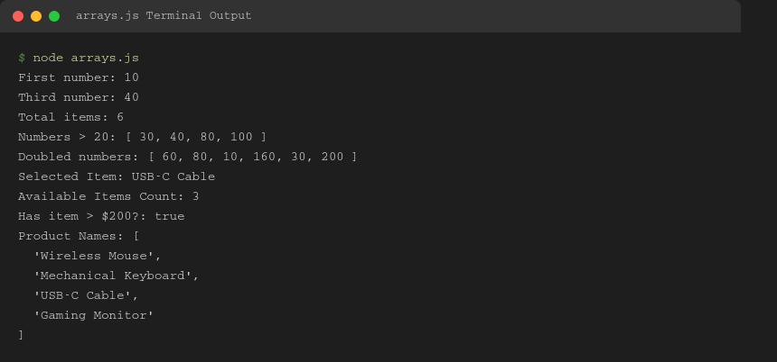
functions.js output
